**Assignment – 6**

Assignment: Build a Student Performance Dashboard using HTML5 Semantic Tags Problem Statement: Design a Student Performance Dashboard using only HTML5 (no CSS or JavaScript) that displays a student's academic information in a structured and meaningful way using the following semantic tags:

<!DOCTYPE html>

<html lang="en">

<head>

  <meta charset="UTF-8">

  <title>Student Dashboard</title>

</head>

<body>

  <header>

    <h1>Student Dashboard</h1>

    <nav>

      <a href="#">Home</a> |

      <a href="#">Subjects</a> |

      <a href="#">Attendance</a> |

      <a href="#">Feedback</a>

    </nav>

  </header>

  <main>

    <section>

      <h2>Student Info</h2>

      <p>Name:Saniya Nishath</p>

      <p>Roll No: 101</p>

      <p>Class: 10th Grade</p>

    </section>

    <section>

      <h2>Marks</h2>

      <table border="1">

        <tr>

          <th>Subject</th>

          <th>Marks</th>

        </tr>

        <tr>

          <td>Full Stack</td>

          <td>90</td>

        </tr>

        <tr>

          <td>Advanced Algorithm</td>

          <td>85</td>

        </tr>

      </table>

    </section>

    <aside>

      <h2>Remarks</h2>

      <p>Good performance. Keep it up!</p>

    </aside>

  </main>

</body>

</html>

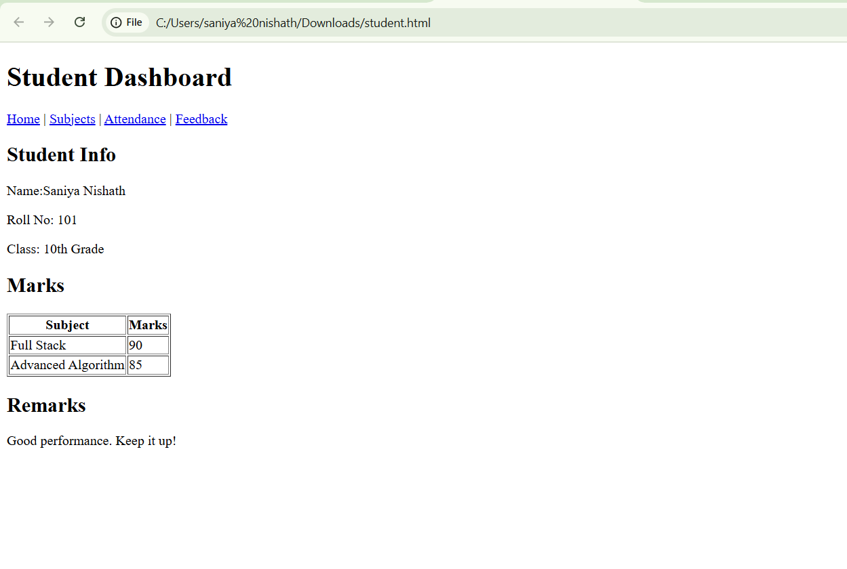

2. Academic Performance Section

<!DOCTYPE html>

<html>

<head>

  <section>

  <h1>Academic Performance</h1>

  <article>

    <h2>Full Stack</h2>

    <p>Date: <time datetime="2025-04-20">20-Apr-2025</time></p>

    <p>Assignments: <progress value="3" max="5"></progress></p>

    <p>Score: <meter value="75" min="0" max="100" low="40" high="90" optimum="95">75%</meter></p>

    <button>Show Comments</button>

  </article>

  <article>

    <h2>Advanced Software Enginnering</h2>

    <p>Date: <time datetime="2025-04-22">22-Apr-2025</time></p>

    <p>Assignments: <progress value="4" max="5"></progress></p>

    <p>Score: <meter value="88" min="0" max="100" low="40" high="90" optimum="95">88%</meter></p>

    <button>Show Comments</button>

  </article>

</section>

</head>

</html>

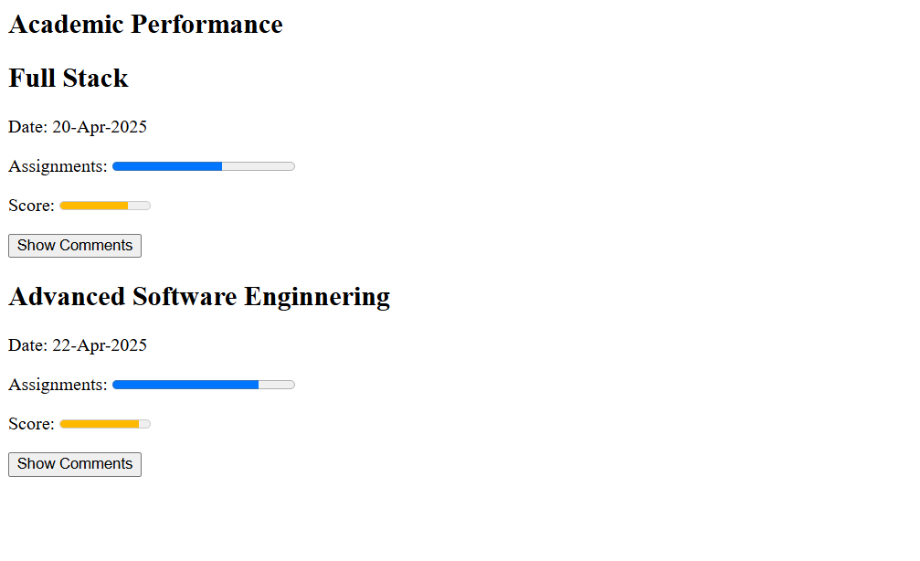

3. Overall Performance Summary

<!DOCTYPE html>

<html>

<head>

  <title>Overall Performance</title>

</head>

<body>

  <section>

    <h1>Overall Performance</h1>

    <p>Average Score:</p>

    <meter value="82" min="0" max="100" low="40" high="90" optimum="95">82%</meter>

    <p>Total Assignments Completed:</p>

    <progress value="7" max="10"></progress>

  </section>

</body>

</html>

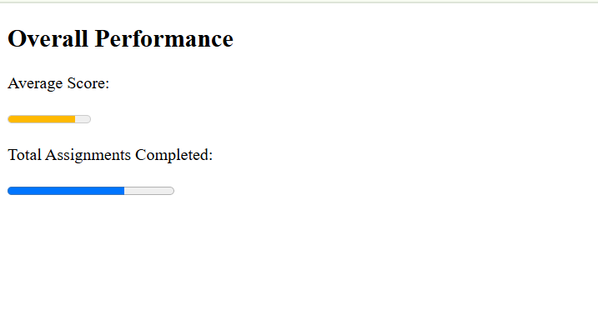

4. Student Information (Sidebar)

<!DOCTYPE html>

<html>

<head>

  <title>Student Information</title>

</head>

<body>

  <aside>

    <h2>Student Profile</h2>

    <p>Name:Saniya Nishath</p>

    <p>Registration No: 2025A028</p>

    <p>Semester:2</p>

    <figure>

      <img src="https://tse4.mm.bing.net/th?id=OIP.eiql0TGCYcn1l_MDSlYpdgHaE8&pid=Api&P=0&h=180" alt="Student Photo" width="150" height="150">

      <figcaption>Saniya Nishath - Profile Photo</figcaption>

    </figure>

  </aside>

</body>

</html>

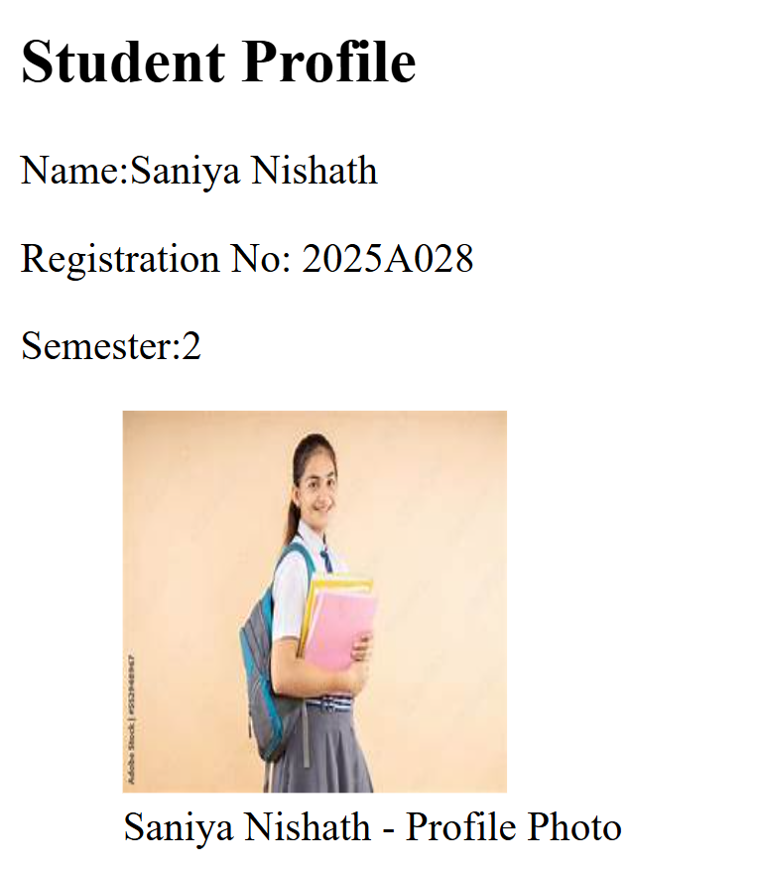

5. Footer

<!DOCTYPE html>

<html>

<head>

  <title>Footer Example</title>

</head>

<body>

  <footer>

    <p>Contact: info@college.edu</p>

    <p>&copy; <time datetime="2025">2025</time> College Name. All rights reserved.</p>

  </footer>

</body>

</html>

